A.A. Area 70  **Full Area Assembly**

**Saturday September 12, 2020**

**Virtual Gathering**

**Zoom Meeting ID 931 0441 4531**

Password: 045396

(For Service Workshop and 1:00 Business Mtg)

**All are welcome*!***

*As part of their duties, G.S.R.s & D.C.M.s attend the Full Area Assemblies.*

*District Committee Chairs are requested to attend.*

**10:00 am** A.A. Service Workshop

**11:00 am** Committee Meetings

**12:00 pm** Lunch Break

**1:00 pm** Business Meeting

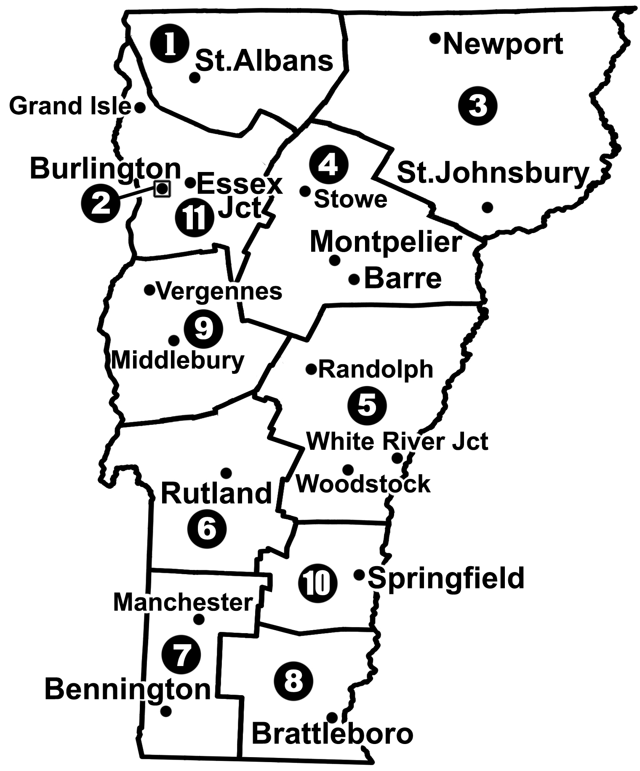

***I Am Responsible*** *. . .*

*When anyone, anywhere, reaches out for help,*

*I want the hand of A.A. always to be there.*

*And for that: I am responsible.\**

*Copyright © The A.A. Grapevine, Inc. Reprinted with permission

**Join us as we work together in service!**

*Meet new and old friends from around the State.*

For more information, go to [www.aavt.org](http://www.aavt.org) or

contact the Area Chair at [area70chair@aavt.org](mailto:area70chair@aavt.org)